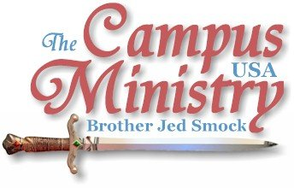
Brojed.org
brojed@aol.com
573-999-0347
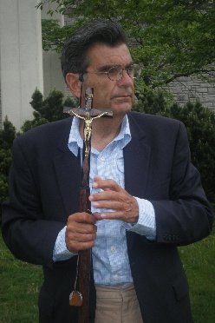
Keep praying for the ministry out west this week and two more...until June 5th.

DESTROYING ALTARS, BREAKING IMAGES AND CUTTING DOWN GROVES
April 27, 2009, Southeast Missouri State University (SEMO),
Bob N., a friend from the Full Gospel Businessmen International, invited Cindy and the girls and me to Cape Girardeau. We usually have no small stir here. Dave and Doris M., a retired couple, who have been discipled under Michael Venya’s campus ministry, joined up with us for a week. Both of them are aggressive reaching out to people individually. Sister Doris preached for a good forty minutes. She is a woman full of the Holy Ghost and fire, who has a strong preaching voice. She reminds Cindy and me of Sister Pat.
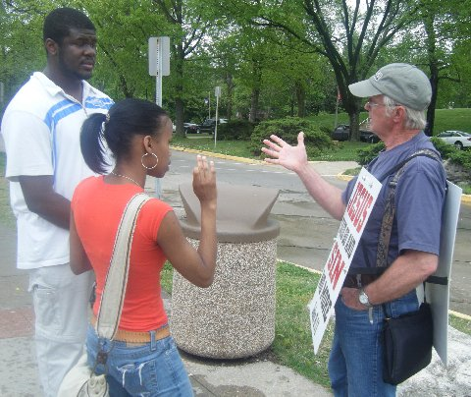
Bro. Dave at his post!
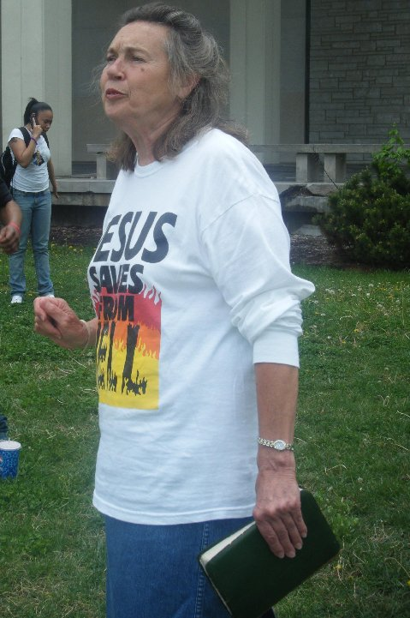
Sister Doris declares the truth.
The students were quite stirred; and we had a crowd of up to 150 students which is good since this is a smaller campus with about 10,000 students. However, in the middle of the afternoon it started to sprinkle; we lost about a third of the crowd. Those that stayed gathered around me in a closer circle and became quiet and attentive. The precipitation soon stopped. Then about 4 PM it started raining harder; I went up to the covered porch of the library. About 25 students followed me to the porch and other students gathered around other members of our team including Priscilla and Martha.

A number of times students insisted, “Tell us a story.” So I related to them parables, some of which include escapades from my college days or experiences in campus preaching; others are stories which I have made up or heard from others to illustrate spiritual truths. The last hour on the porch proved to be a productive time as students were quietly sitting at my feet. Cindy remarked, “I had some of the best conversations that I have had in a long time.”
We were told, “It is all over Facebook that Brother Jed is back.”
Bob N. and his friend, Bob, who had been active in the Mexican Mafia and now has a deliverance ministry, were passing out Voice magazines and prayers for deliverance.
Sarah, the vp of the pagan group Cape Grove, invited me to speak to her student group in the evening. Bob N. and the ex Mafia brother also came to the meeting. They were able to give their witness before I arrived. At 7:15 the meeting was called to order and the president, Christopher, remarked, “We have a bigger crowd than usual.” [I almost always hear that when I am invited to speak to a student group.]

We went around the table with each one briefly introducing ourselves and stating our religious beliefs. The words I heard the most were pagan and eclectic; one girl confessed that she learned witchcraft from her grandmother. I was then introduced. I quoted John 14:6 and the Great Commission informing them that if Jesus was right that they were all wrong and headed for Hell. One student, Cameron, who was older claimed to have attended seminary. He interrupted me making false claims concerning the Canon and the Council of Nicaea. When I replied, there were other interruptions.
I protested and said that I had been invited to speak and that I wanted to make my remarks without interruptions. There was discussion among the group whether that was appropriate for what is supposed to be a discussion group. Finally, the consensus was that they would listen to my spiritual journey. I related my testimony with the students listening attentively. Then I opened up to their questions. These poor souls are really lost and wandering around in the blackness of darkness having built altars, images and groves to false gods. I stayed with them answering their questions which were less contentious after we had established the ground rules. They all had their picture taken with me afterwards. Bob N. and his friend Bob talked with a number of the students in the hallway afterwards for another 45 minutes.

SEMO girls object to the message.
WINSOME GRACE
April 28, 2009, SEMO
There were students already sitting on the wall waiting for us to preach. Cindy soon gathered a crowd of close to 100. David M. with his sandwich board sign was witnessing to students on the sidelines. Cindy, Doris and I took turns preaching. Twice the crowd was broken up by water balloon fights between students with hundreds of balloons. We were not targets of the ballooners; they just seemed to be acting childlike. I suppose it was the spring weather bringing out the child in them. College students are hardly known for their maturity. Each time after their balloons were all thrown the students re-gathered to listen to us.
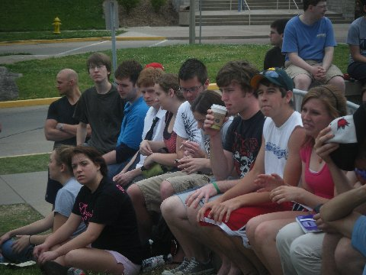
Students sit on the wall at SEMO listening to the Gospel.
Priscilla and I did a duet of the Old Rugged Cross, which she played on her guitar. I have been singing that hymn daily since I have been carrying my crucifix capped staff. Shortly after, a student wept as he thanked me for singing his late grandfather’s favorite hymn. I told the boy he could again see his grandfather in heaven if he would cling to the cross and never let go. I have never met anyone so moved by my singing; or maybe it was Priscilla’s. J.
Dustin, who has expressed his appreciation of our preaching, asked Sister Doris to pray that the Lord would give him strength to get out of a homosexual relationship.

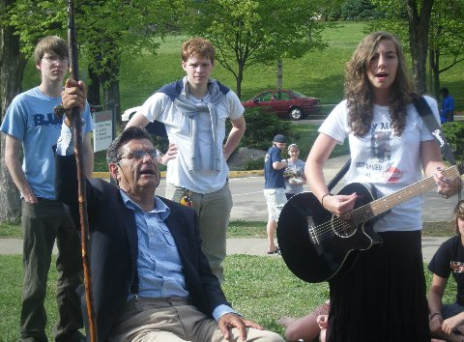
The Old Rugged Cross Duet
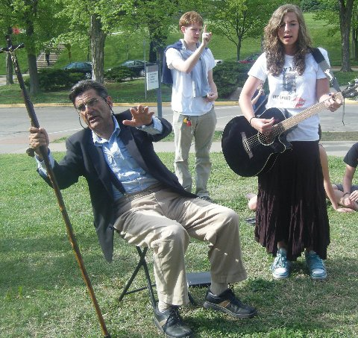
Some of the students from the Cape Grove which I preached to last night in the Student Center were listening most of the afternoon. Cameron, who had initially so vocally protested me yesterday, said today, “Last night I read your book, Who Will Rise Up? on the internet. You are very sound theologically from a Christian perspective.” Cindy was able to talk to him about the fact that it was the Council of Carthage in the late 4th Century that established the Canon, not the Council of Nicaea of 325 AD as he had claimed yesterday. The novel and movie the DeVinci Code has confused many people concerning basic facts of church history.
Sister Doris and Brother Dave said that SEMO is the more open than the campuses that they worked with Michael Venya. I agree that SEMO is relatively open to the gospel. There is a significant Christian influence in the community and evidently their prayers have made a difference. After all, it is Cape Girardeau that has given America the great patriot, Rush Limbaugh.
We left at 5 PM for the four hour drive back to Columbia. Several students expressed disappointment that we were not staying the whole week as we have previous years.


SEMO
SHOWING THEM UP
April 29, 2009, University of Missouri
Sister Doris opened the meeting and gathered a small crowd. She has the ability to go preach on and is never a loss for words. One lipped ringed student who professed Christianity challenged her in the middle of the circle for much of her hour.
Rick, a local minister whom I have written about in the past, was on campus. He asked me, “Are you going to preach after her?”
I said that I had planned to but I would yield to him if he wanted. He was pleased to preach next. He started preaching against our “Arminianism” as I figured that he would. He said, “Justification is being declared righteous. Sanctification is a process and a goal which we never really obtain in this life. When Jesus said, ‘Be perfect,’ He was not talking about our behavior, but that He considered us righteous because of faith in Him; but we are never actually righteous. Repentance is a gift. I notice when I preach the crowd dwindles; but when legalism is preached the crowd grows.”
When I took my turn, I read Matthew 5:48 in the context of the verse which clearly talks about man’s behavior, not imputed righteousness. Actually, loving enemies is a required in order to be considered children of the Father which is in heaven (Matt. 5:45). Repentance is a gift in the sense that God’s gives us the opportunity to repent; but we must change our mind which will result in a change of behavior.
At 3:30 Cindy and the girls arrived on campus. Cindy shook things up for an hour. During my last session, a student asked me what I do besides preach. I mentioned a number of my interests and told the students how I work out daily, including doing 35 push-ups. The student did not believe that I could do 35 push-ups and wanted me to demonstrate. Others chimed in challenging me. I dropped to the concrete and quickly did 35. Some applauded. I shut-up my critics.
AQUILA AND PRISCILLA, WHERE ARE YOU?

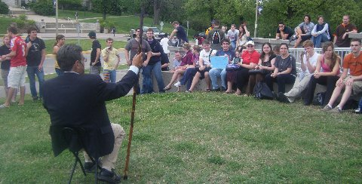
SEMO

May 1, University of Central Missouri,

I started preaching with light precipitation; nevertheless, students gathered and the weather eventually cleared to be a pretty nice day. Sister Doris and Dave accompanied to campus and continued their aggressive evangelism. Doris commented that she met a lot of real Christians who were thankful that we came to campus that day.
May 2, University of Central Missouri,
The temperature dropped today so it was only 50 degrees and windy when I started preaching. Nevertheless, a crowd gathered. At times it rained, still the crowd stayed with us. In the middle of the afternoon, the meeting broke up into three groups. Dave, Doris and I each had a group with which we were interacting. This is the last day that this fiery couple will be with me as over the weekend they headed back to Michigan. However, they want to preach with me some again next school year.
Dave and Doris remind me of what Aquila and Priscilla must have been to helping Paul. I invite other retired couples to join me on the gospel road and help me and be used of the Lord to witness to this lost generation. There are some who read this journal who have the time and the means to hit the road and spiritual grandparents to a generation that rarely have had grandparents or parents who are Christian examples. The students may appreciate your attention more than your own grandchildren. Let me know if you are willing.

I HAVE SINNED
May 4, 2009, University of Missouri
I preached and built up a good crowd. At 12:45 I called on Dr. Acuff, who usually preaches at UM on Mondays. He lost some of the crowd. The second time I spoke I was teaching the holiness doctrine. A student asked me when I last sinned. I decided to take a different approach from usual when asked that question.
I answered, 'I sinned last week.'
That answer got their attention. 'What did you do, Brother Jed?'
I replied, 'I was overcome with pride last week. I demonstrated to doubting students last Wednesday, right here on the Circle, that I could do 35 pushups. I outlasted a 20 year old who tried to match me. I have been bragging about myself ever since. I have been prideful.'
Several of the students had seen me perform my exercise. I think most of them realized that I was speaking tongue in cheek concerning sinful pride. The answer enabled me to deflect the question concerning my own holiness to back on the issue of whether or not the Scriptures teach that man can live holy.
I was building up the crowd again when a male and female, both wearing pony tails, feigned a karate fight which distracted the students. Two boys, who claimed to be absolute naturalists, approached the center of the circle and engaged me in dialogue. I decided to concentrate on them for a while instead of building a crowd again; since I knew Sister Cindy would be arriving soon.
At 2:50 Cindy arrived and started preaching. She built the crowd back up to 50 or so as she preached for the next hour. I preached again from 4-5:15, when I called upon Robert H., whom I met at a FGBMI meeting at the Lake of the Ozarks on Saturday. He told me that he had heard an open air preacher at UM back in the 70's when he was an undergraduate. He said that he walked by at the time; but that the preaching still made an impression upon him which later influenced him to be saved. I informed him that I was probably the one he heard since there were so few campus preachers back in those days. I listened to Robert speak about 5 minutes. He seemed to be handling himself well; so Cindy and I went to dinner. Later, I talked with Robert. He was pleased to report positively concerning his first experience in speaking in the open-air.
THE DEMISE OF THE MONSTER
May 5, 2009, Missouri State University
I started preaching in front of Strong Hall with a permit. In past years JT and his Church of the Flying Spaghetti Monster have soon appeared dressed as pirates using various antics to heckle. However, I was told that JT graduated and his group has diminished. One of them, Ryan the homo, is still around and was present for much of the afternoon.
The first hour I had intelligent questions such as, 'What about the problem of evil?' Which in fact is no problem when one accepts that man has a free will. Similar serious questions were asked, including the question as to why Jesus had to die, which enabled me to expound on the governmental view of the atonement. I was impressed that there are apparently more serious minded students on this campus than I have noticed in past years. With the demise of the CFSM, whose only goal is to mock, those that have some serious theological questions are now able to have a hearing.
After I taught on the atonement a man came out with a bull horn asking various stupid questions and making ridiculous remarks. He presented a serious distraction to carrying on thoughtful dialogue. However, a professor informed me that he called campus security because the bull horn was disturbing classes. Within 10 minutes security shut down the bull horn and the fellow left.
I called upon students to testify for the Lord. One brother gave a good testimony; however, he told students that they cannot do anything to save themselves. I gently corrected him saying that we do have to cooperate with the Holy Spirit. A few other students gave helpful testimonies as to how God had changed their lives.
It started raining shortly after four; so I went inside and carried on a conversation with three students who professed to be Christians. One, who testified outside, remarked on how much I had changed since last year. The fact is that he is the one who has matured in the Lord and seems to have a better understanding of the Word of God and my answers to students' questions.

SEMO

THE MINISTRY OF HELPS
May 6, 2009, MSU
Mr. and Michael B., who are professors at MSU, secured the permit, provided lodging at a local motel, took me to breakfast and gave me a generous offering. If I had just one Christian professor like them on every campus, it would ease the burden of this ministry considerably. Michael was able to spend a few hours with me during the preaching today.
Early in the afternoon, I noticed John who from the look on his face I could tell was receiving my teaching. So I asked him if he was a believer. He indicated that he was but not with the assurance that I would expect. Later, after speaking on discipleship, I asked him in front of the crowd, “Are you willing to commit your life fully onto the Lord?”
He answered positively; so I said, “Go over and speak to that gentleman.” He then walked over and sat down with Michael, who counseled John. Michael is committed to getting him involved in a Bible Study.
Daily, there are students like John in my audience who are ripe for the picking. However, most of the so-called Christians in the crowd are more interested in picking at my methods and message than they are in picking souls for God’s Kingdom.
After 4 PM the crowd had dwindled to maybe 20; I closed in prayer. However, as I was gathering my stuff together, one fellow who had been listening most of the two days came up and began to rail against me, which indicated that he was under conviction but resisting the Holy Spirit. He did calm down after several minutes; and I took another 20 minutes to minister to a group of about eight who were sitting at my feet.
God took of the spirit which was upon Moses and put it on 70 men. And God said to Moses, “They shall bear the burden of the people with thee, that thou bear it not thyself alone (Number 11:17).” Please pray with me that God will raise a professor like Michael B. on each campus to help me bear my burden for the students.
I told Michael as we departed, “You made my ministry on this campus so much more effective.”
TEMPTATION AND SIN

May 7, 2009, University of Missouri
When I arrived at Speakers’ Circle, there were three men passing out tracts. One of them, Jason, had been preaching with a megaphone on the Circle until the police stopped him. Megaphones are not permitted. I talked briefly with each of them. Their tracts promoted holiness.
This was the last day of classes with a study day tomorrow and final exams start next Monday. Students traditionally party hard on this night. There were not as many students on campus as usual today. The first class break I did not draw any of the students into the inner circle. I sat in the circle reading and from time to time reminding students that they had a final exam coming up with God. Gradually, a few students gathered; and I started conversing with them and responding to their questions. Within an hour I had about 25-30 students who had congregated.
Jason took an opportunity to preach and spoke with authority for 15 minutes. I invited the one with a tongue ring, who had just made a profession of faith a few months ago, to give his testimony. He acknowledged that he had been a heavy drug addict until the Lord delivered him. I considered him a diamond in the rough.
One Mizzou student claimed that he was born again when he was a senior in high school. I probed him concerning sin in his life. He confessed to masturbation. He claimed, “By masturbating I control temptation.” I reproved him for trying to exercise self-control through self-indulgence.
This interchange resulted in a lengthy teaching and discussion concerning the difference between temptation and sin. I got through to several students on this difference. Some students do not understand the doctrine of holiness because they confuse temptation with sin.
At the end of the day, I urged the students to read the Bible over the summer, that they would profit intellectually and academically.
Today, I was laid back, not confrontational. I wanted to reaffirm my rapport with the students. Since some I would probably never see again; and others I would not see until the fall semester. I autographed my book for three students. One of them, Morgan, whom I call the tattoo lady asked me to read aloud the section of Who Will Rise Up?, called “Brazen Women.”

MY PILGRIMAGE
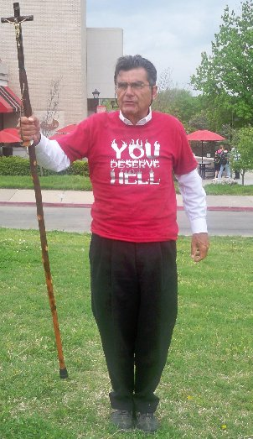
May 11, 2009, University of Washington

When I walked through the Seattle airport on Sunday carrying my staff crucifix a woman asked, “Are you on a pilgrimage?” The more I have thought about the question, I think that is a good word to describe my walk. I have been on a long journey which has lasted thirty seven years. I have been carrying my cross everywhere, especially to university campuses. Don Quixote called it his quest. I am but a stranger and pilgrim here on earth; I seek a city whose builder and maker is God. I am trying to take as many people as possible with me on the journey. Although I mostly travel alone, I am confident that I have inspired countless others to follow.
Today, there was a light rain, wind and cold when I started preaching in Red Square. I did not get a crowd; so I went to the library and read in Hebrews. By the next break it was raining hard. I thought I would preach under my umbrella; but the wind was so strong it turned my umbrella inside out. I did not preach; but I returned to the library and finished Hebrews. Hebrews 13:13-14 encouraged me; it reads, “Let us go forth therefore unto him without the camp, bearing his reproach. For here we have no continuing city, but we seek one to come.”
I needed encouragement because the weather was not looking good for the whole week and I had come a long way at a significant expense. Today looked like it was going to be a washout. But by the 1:20 break the rain had stopped and the wind had died down considerably.
A long haired bearded fellow with a small wooden cross and guitar was singing in the middle of Red Square. I started far enough away from him so as not to interfere with his witness. I had only been preaching for a moment when a screamer got within inches of my faces and said, “I believe in the devil. I want to go to Hell. I want to be among the rulers in Hell. Where is the devil, is he on Earth or in Hell?”

I answered, “Satan has access to both places. He is speaking to you and through you now.” Evidently, the screamer was in such a frenzy that he did not hear because he kept asking me the same question.
I said, “You claim to believe in the devil. Tell me about him. What is his origin?”
He could not answer this question and after about 10 minutes he left, presumably to go unto to class, where likely he will hear more lies from the devil. I know the devil well. I served him for many years; but now I have been fighting him for many more years. This screamer knew little of the devil and his ways.
I took full advantage of the screamer. The Lord was using the confrontation to draw a crowd of about 20 students to sit on the steps. Meanwhile, the hippy looking young man with the guitar came over and started singing and speaking to my crowd and trying to answer their questions, evidently thinking he could do the job better. I reproved him for he was a distraction. He settled down somewhat but still interrupted from time to time over the next two hours.
I had generally civil dialogue for the next two hours. At 3:30 virtually everyone left. So I sat down on the steps. The hippy looking Christian with the guitar stood up and starting reading John 10 from his King James Bible and made some comments as he read. The young fellow held to fundamental Christian beliefs. I decided to wait around to see if I could have some fellowship with him. After a while he moved to the center of the Square where Greeks were having some gathering and he preached to them. At 4:30, he was still speaking and singing. He has not learned any skills of communication to capture peoples’ attention. I tired of waiting for him to stop; so I left campus.
The UW Daily did an opinion piece on me, “Brother Jed: Evangelical loon or marketing genius?:
http://dailyuw.com/2009/5/11/brother-jed-evangelical-loon-or-marketing-genius/

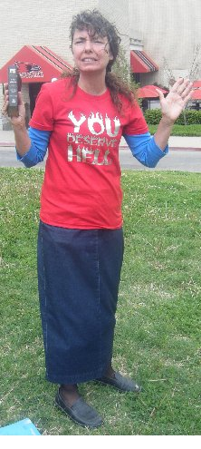
SEMO
A PSALM OF DELIVERANCE
May 12, 2009, University of Washington
A Moslem wanted to read something from my Bible; I did not trust him; so I said that I would read the passage which he requested, Psalm 18:10, “God rode upon a cherub, and did fly: yea, he did fly upon the wings of the wind.”
The literalist Moslem wanted to know how God could ride upon a cherub since cherubs are portrayed in the Vatican as baby angels. I explained that the passage was figurative. Also, that we do not have a Biblical description of these angelic beings. Just because cherubs are portrayed in art as winged babies that does not necessary mean that is actually the case of all cherubs.
Moslems hate the cross so I pointed to my crucifix and said the main problem with Islam is that it denies that Jesus died on the Cross and rose from the dead. Yet these deceivers claim to honor Jesus in their religion. All of this eventually developed into a discussion on the nature of the Trinity which the Koran directly denies. Islam teaches that when Jesus returns, he is going to destroy all crosses. But God is going to destroy the Islamists with hail stone, coals of fire, lightening and a blast of the breath of His nostrils when He comes again.
A thoughtful young man with a Catholic background asked me how it was just for Jesus to be punished for the sins of men. I answered that God did not punish Jesus, that God substituted His Son’s sufferings at the hands of wicked men as atonement for the penalty of sin which is eternal damnation. I was able to give a teaching on the atonement to a fairly attentive group.
The student who asked me the question on the alleged punishment of Jesus by His Father repeatedly said that he had to go to his class in Islam; however, he kept coming up with other thought provoking questions. He either never made it to class or he was very late. Before he left, I asked him if a Moslem taught the class on Islam. He answered in the affirmative. I have noticed that usually Moslems teach classes in Islam; but it is unusual that Christians teach classes dealing with Christianity and the Bible. And should a Christian teach one of these classes they are usually much more concerned about objectivity than these Moslem professors. It is not unusual for atheists to be teaching a class in Christianity. I have never heard of an atheist teaching a class on Islam.
Around 4 PM two squad cars drove into Red Square. A policeman had the audacity to tell me that I was violating the first amendment by offending people. He claimed that he had received two complaints. I assumed that the calls had either come from homosexuals or Moslems. They are the ones that usually call the police. The policeman acknowledged that he heard I was saying things against homosexuals and other religions very loudly. He was trying to dictate the content of my speech. I explained that the Constitution is designed to protect offensive speech not polite speech. Polite speech needs no protection. He left claiming that I could not “yell and scream” at people; but I could continue talking quietly to the group of about 12. I explained what he called yelling and screaming is preaching; that over the last two days several homosexuals had been in my face doing the yelling and screaming. I did not argue further with him since I was not intending to loudly lift up my voice for the rest of the afternoon; but I continued to engage in quiet dialogue with attentive students until 5:40 PM.
All in all is consider it a very profitable today considering that it was a clouded day in the low 50s with threatening rain.
As I walked by back to my cell in a rooming house five blocks from campus which has welcomed me while I preach in Washington, I felt like David must have felt after a day of battle as described in Psalm 18, “For by thee I have run through a troop; and by my God have I leaped over a wall…For He teacheth my hands to war, so that a bow of steel is broken by mine arms. For thou hast girded me with strength unto the battle: thou hast subdued under me those that rose up against me.”
SEMO
EMBOLDING THE BRETHREN
May 13, 2009, University of Washington

Paul wrote to the Philippians, “And many of the brethren in the Lord, waxing confident by my bonds, are much more bold to speak the word without fear.”
The landlord, Joyce, of the rooming house in which I am staying came out to campus with Chris and Ivina two girls who live on the top floor. I am in the basement with the men. Staying in the off campus house is almost like being back in college.
The three women are mature Christians and immediately became active in witnessing to the students who gathered. There was an atheist woman who appeared to be in her 40s, who said publicly her father was a pastor. Chris and Ivana both talked with her. The woman said that she had not had a conversation with anyone concerning faith for years. The girls report that she was opened and that she concluded, “Who knows, I might end up a fundamentalist.”
Today the weather was cold and windy and when a light rain started the students scattered. I waited around for another class break; but by then it was raining harder. I decided to call it a day; I was happy to get in a good hour of preaching. The ladies from the rooming house were happy that my preaching had provided opportunities for them to witness.
Yesterday, I received the following email:
Brother Jed,
Today I was walking from class and trying to go home.. but earlier in the Day I prayed to God that I could be used for his glory that he could position me in a place where he could use me like no other way before. as I turned the corner I saw these two morrmans praying and talking with a man, I prayed that God would not allow him to not believe in Mormonism and believe in the one true God.. then I turned another corner and saw you preaching, I thought to myself oh I will listen for only 5 minutes, I will stand here praying for brother Jed, praying that God can use you to open the eyes and hearts of my fellow students. let me tell you 5 minutes turned into 2 hours of nearly my heart crying out for my fellow students who were acting out in anger, fear, and being so lost in sin. I still sit here tonight broken for these fellow students that God so wants to follow him, but yet they won’t. I am so blessed to know that you were willing to sit down and talk to students on the steps, you blessed me, and taught me.

After sitting on the steps, you got back up and spoke truth, I don't know what happened after I left but I walked the one guy to class and we stood in the hallway talking for another 10 minutes, in fact he told me that I should go back to you and tell you to stop what you are doing because it is useless and turning people away from Christ, I DIDN'T.. because I know what you are doing is stirring up the hearts and fears of non-believers, teaching and encouraging believers...

with all this to say, THANK YOU FOR COMING TO THE UW!!
Lindsay J.
This afternoon I received another email from Lindsey:

I did talk to some of the people that came to hear you today, it was amazing to see God work in the conversations. what got me most was seeing the desperate faces and people who were honestly searching for God and new deep down they needed him.. one Boy I saw his face when he was talking to you today and in his face I saw hurt and pain.. it hurt me so much.. let me tell you this has been a wake up call to reality of young people who do not believe in Jesus. I was talking to other Christians and we went to sit on the steps together and we felt like we didn't know how to speak truth and to prove that God did exist, in some ways I feel unequipped as a Christian to share the Gospel with other people but these past 2 days I learned that I need to stretch and be willing to talk about my faith.. I will see you on Friday! I will be sure to stop by and introduce myself on Friday.

Lindsay
DEJA VU

May 14, 2009, Evergreen State College,

Matt Groening, cartoonist and creator of “The Simpsons,” said,” "I went to college in Olympia, Washington, a fine little progressive school called Evergreen State College, state-funded, no grades, no hard courses. I highly recommend it to all self-disciplined creative weirdoes."
The college specializes in environmental studies and is located in an evergreen forest off the Puget Sound waterfront. There is an organic farm on the campus. The college was founded in 1967, which is the year of the summer of love in the Haight Asbury district of San Francisco, where the hippies gathered and formed a melting pot of psychedelic drugs, rock music, sexual indulgence, communal living and irresponsible, bizarre self-indulgent behavior. Evergreen College remains in a sixties time warp. The whole scene took me back in my mind to my hippy days.
I started preaching in the midst of the bricked square with the ugliest buildings of all the campuses which I have visited: grey concrete everywhere, much like one might see in Eastern Europe. Two girls were selling organic vegetables from a stand in front of me. They danced as I preached; I mocked them for their capitalistic enterprise. Several vegetarians were stuffing their mouth with lettuce, turnips, etc. as I preached. One boy brought out a large sign which read, “There is no God.” [Later, someone came by and removed the letters “no,” making the sign say, “There is God.”] Another boy fell to the ground and slivered like a snake.
Robert Ephrata, from Bellingham, WA, accompanied me to campus and we shared the preaching duties. Robert carried a large banner and wore a lettered message jacket. We never gathered a crowd of more than 20 (enrollment 4500 students). All afternoon we had students with whom we talked. There must not be regularly scheduled classes since there were no significant class breaks with masses passing through the square. Students mostly were coming in and out of the library.
From 2-4:15, Robert and I each had a group of students around us. My group session was profitable. The group was initiated by a discussion I had with a girl who had tried Christianity, but had settled on Buddhism. I asked, “Why do you think Buddha’s teachings are superior to those of Jesus?” For almost an hour we contrasted Nirvana with Heaven, the Buddhist concept of self-denial with that of the Christian concept. I also dialogued with atheists. Two Christians came up who sided with me in defending the existence of God. When the group broke up each one shook hands with me and thanked me for coming.
Robert and I rejoiced over the day. We were concerned that we might be rained out since it rained heavily most of the way from Seattle to Olympia; however, shortly before we arrived on campus it stopped raining and in the mid afternoon we even had sunshine.
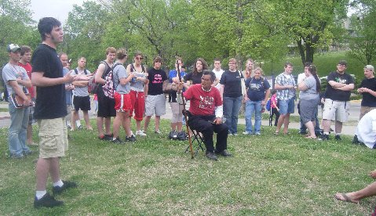
Regular heckler at SEMO
“THOSE JEWS WHICH BELIEVED”
May 15, 2009, University of Washington
Lindsay sat on the steps of Red Square soon after I started and listened and witnessed most of the afternoon.
Amanda confronted me and said, “I was once a Christian until I got an education in college.” She argued with me for a while and then sat down. The dialogue was civil and lively as I preached for two and one half hours to a group of 20 or so. Street Preacher, Lance Thomas, stood at a distance behind me carrying a sign which warned sinners of various sins including the one that seem to get the most comment, “sports nuts.”
About 1:45, I gave Lance as opportunity to preach. I should have turned the meeting over to him earlier; but the questions were coming quickly and there did not seem to be a good transition time previously.
As I walked up the steps, Amanda, asked, “Where are you going?”
“I am going to sit down in the chairs on the patio, would you like to join me and talk?” I replied.
We talked for over an hour. She told me of her experience of asking Jesus into her heart in high school. That she had actively witnessed and taught youth the way of the Lord. But when she came to college she concluded that her experience was not real, although at other times she talked like it was real. I pressed her on whether she had actually ever forsaken all sin. She answered that we all sin and that we can never stop sinning.
I explained to her the dangers of basing one’s faith just on experience. Our experience must be rooted in Truth and understanding.
Jesus said, “to those Jews who believed on him. If ye continue in my word, then are ye my disciples indeed: And ye shall know the truth, and the truth shall make you free (John 8:31-32).” Verse 32 is often taken out of context. “Those Jews” believed but evidently not unto salvation. Jesus explained that they must continue in his word to be his disciples. In verse 33 “those Jews” claimed to be Abraham’s seed. In verse 34 Jesus answered them, “Verily, verily, I say unto you, Whosoever committeth sin is the servant of sin. And the servant abideth not in the house for ever: but the Son abideth ever. If the Son therefore shall make you free, ye shall be free indeed.”
Jesus proceeded to accuse those Jews of seeking to kill him because they did not truly have his word neither would they hear his words. He accused them of being children of the devil. Finally, he said, “Verily, verily, I say unto you, If a man keep my saying, he shall never see death (vs. 51).”
Amanda believed like “those Jews,” who knew he was the Messiah but refused to obey; therefore, they were still dead in their trespasses and sins. She was never free from sin according to her own testimony; therefore, her experience was not deep enough to continue in the Lord’s word. She had little understanding of the necessity of making Jesus the Lord of her life. Eventually, she had to go off to her Human Sexuality class, which she defended from a moral relativist point of view. I fear our churches are filled with people who believe like “those Jews.”
Meanwhile, a young man, who had stopped and was listening to our conversation, was engaged by Lindsay in talk. She had a long witness with him.
I pulled my chair up to listen to Lance. Evolution was the main topic with which Lance had to deal. Lance explained that evolution is a religion and not scientific because there is no evidence to support it. Lance explained that he is a religionist, not a scientist; and if they wanted answers to some of the more difficult questions they should go to: answersingenisis.org.
Lance is a machinist, who preaches mostly at events. I liked his low key, laid back, unassuming style. Lance has a serious demeanor, but with a dry sense of humor. There was a persistent evolutionist who tended to go off on diatribes using the scientific vocabulary that the layman would not understand and whose arguments the average person, including myself, could not follow. Lance’s response was, “You must be in line to be the next Stephen Hawking. You are way beyond my expertise, go to: answersingenisis.org.” The only street preacher I know who could have handled this high minded Hawking wannabe would be Bro Cope.
About 4:45 Lance asked if I wanted to call it a day. I determined that the students were ready to hear the story of how I came to the knowledge that there was a God and that Jesus was God in the flesh. The students were very attentive as I related my testimony. Afterwards, I responded to questions.
A bearded white headed fellow with a straw hat and shorts asked me a question. I no sooner got a few sentences out of my mouth and he interrupted and started preaching that all paths lead to God. Then he would ask me another question only to quickly interrupt and return to preaching his Unitarian Universalism with a mystical slant. He seemed to fancy himself as some sort of guru. Soon he was in my face and we had a loud interchange. After about 15 minutes he walked off. Lindsay asked him a question and he sat down and talked to her.
Later Lindsay reported her conversation with the guru guy, “I got absolutely no where, he was definitely filled with false teaching... what he said was wrong, he kept saying that we were filled with our own universal Jesus who is living in us, and we make him what we want... I sat there and told him the truth... it was definitely frustrating... but I let him go and tried to show him Jesus..and that's all that we could do..”
It was 5:30 by now and only a few students were left. So I decided to end the preaching. Lance had already left. As I walked off, a girl came up to tell me how much she appreciated hearing the story of my conversion.
Pray that the Lord will call more students like Lindsay who are willing to work with me to do a work for the Lord while I am on campus.
